**Social Media Analytics**

*A project report submitted to ICT Academy of Kerala*

*in partial fulfillment of the requirements*

*for the certification of*

**CERTIFIED SPECIALIST**

**IN**

**DATA SCIENCE & ANALYTICS**

submitted by

**Shaima Jinsy P A**

**Musthafa Neduvanchery**

**Haneena V P**

**Adarsh B**



**ICT ACADEMY OF KERALA**

**THIRUVANANTHAPURAM, KERALA, INDIA**

**Dec 2023**

**List of Figures**

| Figures 1 | Implementation Plan | 9 |
| --- | --- | --- |
|  |  |  |
|  |  |  |

**List of Abbreviations**

|  |  |  |
| --- | --- | --- |
|  |  |  |
|  |  |  |

**Table of Contents**

| 1. | Abstract | 5 |
| --- | --- | --- |
| 2. | Problem Definition | 8 |
| 3. | Introduction | 7 |
| 4. | Literature Survey | 9 |

**Abstract**

The growing impact of fake news on social media and communication necessitates improved detection methods. An important objective in enhancing the reliability of information in online social networks is to promptly identify fake news. However, limited resources have hindered progress in this area. Therefore, this project aims to investigate and implement a platform for accurately detecting fake news. The proposed dataset, named *'fake_news_dataset.csv'*, is compiled from various publicly available datasets on US domestic politics and international affairs. We have combined similar columns and merged relevant features into a single dataset. By utilizing diverse machine learning algorithms and ensemble methods, the project aims to evaluate their performance and develop a web application for fact-checking fake news. The absence of labeled benchmark datasets has constrained statistical approaches, underscoring the significance of this endeavor. Ultimately, this project addresses the critical need to combat fake news and contributes to the trustworthiness of information in online social networks.

**1. Problem Definition**

**1.1 Overview**

**1.2 Problem Statement**

**2. Introduction**

**3. Literature Survey**

**4. Implementation Plan**

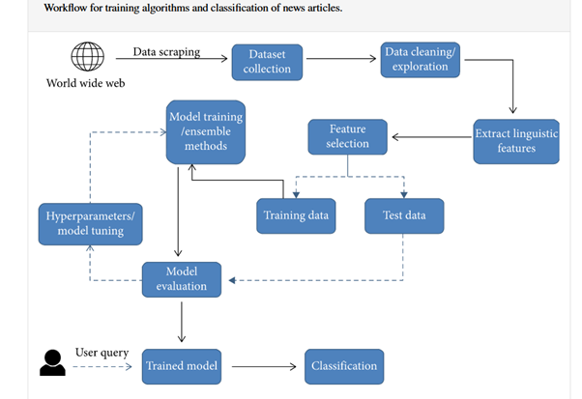

**7. Result**

**8. Conclusion**

**References**

**Dataset:**

1. <https://data.mendeley.com/datasets/945z9xkc8d/1>
2. [https://github.com/topics/fake-news-detection](https://github.com/topics/fake-news-detectipn)
3. <https://kaggle.com/code/abhishek09/fake-news-dataset-beginner/input>
4. <https://kaggle.com/datasets/mohamadalhasan/a-fake-news-dataset-around-the-syrian-war>